Matplotlib
Matplotlib is easy to use and an amazing visualizing library in Python.

import matplotlib.pyplot as plt

# initializing the data
x = [10, 20, 30, 40]
y = [20, 30, 40, 50]

# plotting the data
plt.plot(x, y)

# Adding the title
plt.title("Simple Plot")

# Adding the labels
plt.ylabel("y-axis")
plt.xlabel("x-axis")
plt.show()

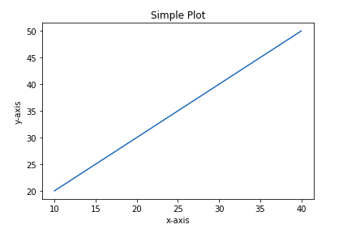
Figure class
Figure class is the top-level container that contains one or more axes. It is the overall window or page on which everything is drawn.
from matplotlib.figure import Figure
# Python program to show pyplot module
import matplotlib.pyplot as plt
from matplotlib.figure import Figure

# Creating a new figure with width = 5 inches
# and height = 4 inches
fig = plt.figure(figsize =(5, 4))

# Creating a new axes for the figure
ax = fig.add_axes([1, 1, 1, 1])

# Adding the data to be plotted
ax.plot([2, 3, 4, 5, 5, 6, 6],
[5, 7, 1, 3, 4, 6 ,8])
plt.show()

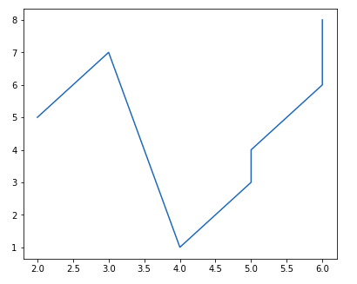
Axes Class
Axes class is the most basic and flexible unit for creating sub-plots. The axes() function creates the axes object.

# Python program to show pyplot module
import matplotlib.pyplot as plt
from matplotlib.figure import Figure
fig = plt.figure(figsize = (5, 4))

# Adding the axes to the figure
ax = fig.add_axes([1, 1, 1, 1])

# plotting 1st dataset to the figure
ax1 = ax.plot([1, 2, 3, 4], [1, 2, 3, 4])

# plotting 2nd dataset to the figure
ax2 = ax.plot([1, 2, 3, 4], [2, 3, 4, 5])
plt.show()

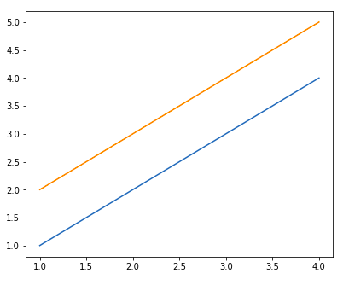
Creating Different Types of Plots
Line Graph
import matplotlib.pyplot as plt
# data to display on plots
x = [3, 1, 3]
y = [3, 2, 1]

# This will plot a simple line chart
# with elements of x as x axis and y
# as y axis
plt.plot(x, y)
plt.title("Line Chart")

# Adding the legends
plt.legend(["Line"])
plt.show()

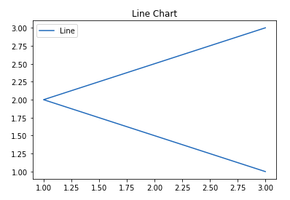
Bar chart
A bar plot or bar chart is a graph that represents the category of data with rectangular bars with lengths and heights that is proportional to the values which they represent.
The bar plots can be plotted horizontally or vertically.

import matplotlib.pyplot as plt
# data to display on plots
x = [3, 1, 3, 12, 2, 4, 4]
y = [3, 2, 1, 4, 5, 6, 7]

# This will plot a simple bar chart
plt.bar(x, y)

# Title to the plot
plt.title("Bar Chart")

# Adding the legends
plt.legend(["bar"])
plt.show()

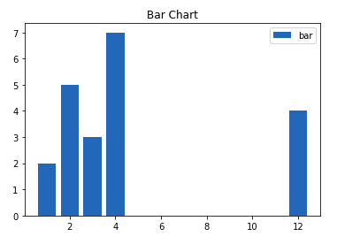

Pie charts

import matplotlib.pyplot as plt
labels = 'Frogs', 'Hogs', 'Dogs', 'Logs'
sizes = [15, 30, 45, 10]

fig, ax = plt.subplots()
ax.pie(sizes, labels=labels)

